Advanced PL/SQL –

Preventing SQL Injection Attacks

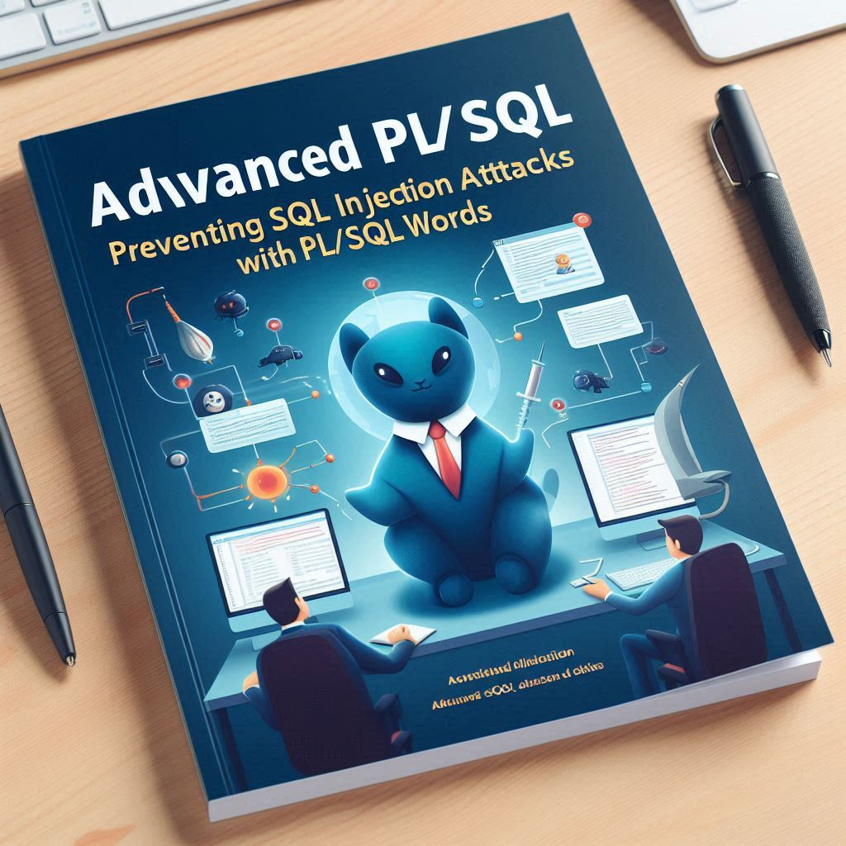
An introduction and overview

This booklet will cover best practices for preventing SQL Injection attacks, including input validation, parameterized queries, stored procedures, and the principle of least privilege. By following these guidelines, developers can significantly reduce the risk of SQL Injection and ensure the security and integrity of their applications.

By Randall Fadler September 2024

Table of Contents
1. Introduction 3
Overview of SQL Injection Attacks 3
Importance of Preventing SQL Injection Attacks 3
Signs of a SQL Injection Attack 4
2. Best Practices for Preventing SQL Injection Attacks 5
Use Bind Variables 5
Parameterized Queries 5
Benefits of Using Bind Variables and Parameterized Queries 6
Examples of Vulnerable Dynamic SQL 7
Dynamic SQL with Concatenation, example 1: 7
Dynamic SQL with Concatenation, example 2: 7
Vulnerable Login Query: 8
Search Query with User Input: 8
Use DBMS_ASSERT Package 9
Use Static SQL Whenever Possible 9
Validate and Sanitize User Inputs 9
Use Least Privilege Principle 10
Role-Based Access Control (RBAC): 10
Granting Specific Privileges: 10
Using Secure Application Roles: 10
Limiting System Privileges: 11
Using Fine-Grained Access Control (FGAC): 11
Use PL/SQL Packages and Procedures 12
Regular Security Audits and Code Reviews 12
Using the DBMS_SQL package 13
List of Procedures 14
Examples of using DBMS_SQL: 15
Executing a Dynamic Query: 15
Handling Dynamic Columns: 15
Using the DBMS_ASSERT Package 16
List of Procedures 17
Examples of using DBMS_ASSERT 17
Validating a Single Quoted Literal: 17
Validating a Qualified SQL Name: 18
Validating a SQL Object Name: 18

1. Introduction

Overview of SQL Injection Attacks

SQL Injection is a type of cyber-attack where an attacker exploits vulnerabilities in an application’s software by injecting malicious SQL code into a query. This can occur when user inputs are not properly sanitized or validated, allowing the attacker to manipulate the SQL query to execute arbitrary commands. The consequences of SQL Injection can be severe, including unauthorized access to sensitive data, data corruption, and even complete control over the database server. Attackers can use SQL Injection to bypass authentication mechanisms, retrieve hidden data, and execute administrative operations. It is a critical security concern for any application that interacts with a database, and developers must be vigilant in implementing protective measures.

Importance of Preventing SQL Injection Attacks
Preventing SQL Injection attacks is crucial for maintaining the security and integrity of any application that interacts with a database. SQL Injection can lead to unauthorized access to sensitive information, such as personal data, financial records, and intellectual property. For example, an attacker might exploit a vulnerable login form by injecting malicious SQL code to bypass authentication and gain access to user accounts. This could result in identity theft, financial fraud, or exposure of confidential information. Another example is an attacker manipulating a search query to retrieve hidden data, such as customer lists or proprietary business information, which could be used for competitive advantage or sold on the black market. Additionally, SQL Injection can be used to execute administrative operations, such as deleting or modifying data, which can disrupt business operations and cause significant financial losses. By implementing robust security measures, such as input validation, parameterized queries, and least privilege principles, developers can protect their applications from SQL Injection attacks and ensure the confidentiality, integrity, and availability of their data

Signs of a SQL Injection Attack
Detecting a SQL Injection attack can be challenging, but there are several common signs that may indicate an attack is occurring:
- Unexpected Database Errors: If your application suddenly starts generating unusual or unexpected database errors, it could be a sign of SQL Injection. These errors might reveal information about your database structure or query syntax.
- Unusual Activity in Logs: Monitoring your database and application logs for unusual activity, such as unexpected queries or a high volume of requests, can help identify potential SQL Injection attempts.
- Changes in Application Behavior: If your application starts behaving erratically, such as displaying incorrect data, allowing unauthorized access, or experiencing performance issues, it could be due to a SQL Injection attack.
- Unauthorized Data Access: If you notice that sensitive data is being accessed or modified without proper authorization, it could be a result of SQL Injection.
- Unusual User Activity: Monitoring user activity for unusual patterns, such as repeated failed login attempts or accessing parts of the application they shouldn’t, can help identify potential SQL Injection attacks.
By being vigilant and monitoring for these signs, you can detect and respond to SQL Injection attacks more effectively. Implementing robust security measures, such as input validation and parameterized queries, can also help prevent these attacks from occurring in the first place.

2. Best Practices for Preventing SQL Injection Attacks
Preventing SQL injection in PL/SQL code is crucial for maintaining the security and integrity of your database. Here are some of the best practices to prevent SQL injection:

Use Bind Variables
Bind variables are placeholders in SQL statements that are replaced with actual values at runtime. This approach ensures that user inputs are treated as data, not executable code. Here’s an example in PL/SQL:

PROCEDURE GetEmployeeDetails(p_emp_id IN NUMBER) IS
v_emp_name VARCHAR2(100);
BEGIN
SELECT emp_name INTO v_emp_name FROM employees WHERE emp_id = :emp_id;
DBMS_OUTPUT.put_line('Employee Name: ' || v_emp_name);
END;

Parameterized Queries
Parameterized queries are another way to safely include user inputs in SQL statements. Using parameterized queries is a great way to prevent SQL Injection attacks and ensure the security of your database. Here’s an example of how to use a parameterized query in Oracle using PL/SQL:

DECLARE
v_empno NUMBER := 7369; -- Example employee number
v_ename VARCHAR2(50);
BEGIN
-- Using a parameterized query with bind variables
SELECT ename
INTO v_ename
FROM emp
WHERE empno = :empno;

DBMS_OUTPUT.PUT_LINE('Employee Name: ' || v_ename);
EXCEPTION
WHEN NO_DATA_FOUND THEN
DBMS_OUTPUT.PUT_LINE('No employee found with the given employee number.');
WHEN OTHERS THEN
DBMS_OUTPUT.PUT_LINE('An error occurred: ' || SQLERRM);
END;
In this example:
- The v_empno variable is used to store the employee number.
- The SELECT statement uses a bind variable :empno to safely include the employee number in the query.
- The INTO clause is used to store the result of the query in the v_ename variable.
- The DBMS_OUTPUT.PUT_LINE procedure is used to display the employee name.
By using bind variables, you ensure that user input is safely included in the SQL statement, reducing the risk of SQL Injection attacks. This booklet will cover more examples and best practices for using parameterized queries to help you secure your Oracle PL/SQL applications.

Benefits of Using Bind Variables and Parameterized Queries
- Prevents SQL Injection: By treating user inputs as data, it prevents malicious inputs from being executed as part of the SQL statement.
- Improves Performance: Bind variables can improve performance by allowing the database to reuse execution plans for similar queries with different inputs.
- Enhances Security: It ensures that user inputs are properly escaped and handled, reducing the risk of SQL injection attacks.

Examples of Vulnerable Dynamic SQL
Here are some examples of a vulnerable dynamic SQL statement that should be modified to prevent attacks:

Dynamic SQL with Concatenation, example 1:

PROCEDURE GetEmployeeDetails(p_emp_id IN NUMBER) IS
v_sql VARCHAR2(200);
v_emp_name VARCHAR2(100);
BEGIN
v_sql := 'SELECT emp_name INTO v_emp_name FROM employees WHERE emp_id = ' || p_emp_id;
EXECUTE IMMEDIATE v_sql;
DBMS_OUTPUT.put_line('Employee Name: ' || v_emp_name);
END;

In this example, if p_emp_id contains a malicious input like 1 OR 1=1, it could lead to an SQL injection attack.

Dynamic SQL with Concatenation, example 2:
DECLARE
v_query VARCHAR2(1000);
v_username VARCHAR2(50) := 'user_input';
BEGIN
v_query := 'SELECT * FROM users WHERE username = ''' || v_username || '''';
EXECUTE IMMEDIATE v_query;
END;
In this example, if v_username contains malicious input like user_input' OR '1'='1, the query becomes:
SELECT * FROM users WHERE username = 'user_input' OR '1'='1'
This would return all rows from the users table, bypassing any authentication checks.

Vulnerable Login Query:

DECLARE
v_query VARCHAR2(1000);
v_username VARCHAR2(50) := 'user_input';
v_password VARCHAR2(50) := 'pass_input';
BEGIN
v_query := 'SELECT * FROM users WHERE username = ''' || v_username || ''' AND password = ''' || v_password || '''';
EXECUTE IMMEDIATE v_query;
END;
If an attacker inputs user_input' OR '1'='1 for the username and anything for the password, the query becomes:
SELECT * FROM users WHERE username = 'user_input' OR '1'='1' AND password = 'anything'
This would allow the attacker to bypass the login authentication.

Search Query with User Input:

DECLARE
v_query VARCHAR2(1000);
v_search_term VARCHAR2(50) := 'search_input';
BEGIN
v_query := 'SELECT * FROM products WHERE name LIKE ''%' || v_search_term || '%''';
EXECUTE IMMEDIATE v_query;
END;
If v_search_term contains search_input%' OR '1'='1, the query becomes:
SELECT * FROM products WHERE name LIKE '%search_input%' OR '1'='1'
This would return all rows from the products table, potentially exposing sensitive data.
To prevent SQL Injection attacks, it is essential to use parameterized queries, bind variables, and input validation. This booklet will cover these best practices in detail to help you secure your Oracle PL/SQL applications.

Use DBMS_ASSERT Package
The DBMS_ASSERT package provides functions to validate and sanitize user inputs.

PROCEDURE GetEmployeeDetails(p_emp_id IN VARCHAR2) IS
v_emp_id NUMBER;
v_emp_name VARCHAR2(100);
BEGIN
v_emp_id := DBMS_ASSERT.simple_sql_name(p_emp_id);
SELECT emp_name INTO v_emp_name FROM employees WHERE emp_id = v_emp_id;
DBMS_OUTPUT.put_line('Employee Name: ' || v_emp_name);
END;

Use Static SQL Whenever Possible
Static SQL is precompiled and does not allow for dynamic user input, reducing the risk of SQL injection.

PROCEDURE GetEmployeeDetails(p_emp_id IN NUMBER) IS
v_emp_name VARCHAR2(100);
BEGIN
SELECT emp_name INTO v_emp_name FROM employees WHERE emp_id = p_emp_id;
DBMS_OUTPUT.put_line('Employee Name: ' || v_emp_name);
END;

Validate and Sanitize User Inputs
Always validate and sanitize user inputs to ensure they conform to expected formats and values.

PROCEDURE ValidateInput(p_input IN VARCHAR2) IS
BEGIN
IF NOT REGEXP_LIKE(p_input, '^[0-9]+$') THEN
RAISE_APPLICATION_ERROR(-20001, 'Invalid input');
END IF;
END;

Use Least Privilege Principle
The principle of least privilege is a fundamental security concept that involves granting users and applications the minimum level of access necessary to perform their tasks. In the context of Oracle databases, this principle helps to minimize the risk of unauthorized access, data breaches, and other security incidents. Here are some key aspects and examples of implementing the least privilege principle in Oracle:

Role-Based Access Control (RBAC):
  - Create roles with specific privileges and assign them to users based on their job functions.
  - Example:
-- Create a role with specific privileges
CREATE ROLE read_only_role;
GRANT SELECT ON employees TO read_only_role;

-- Assign the role to a user
GRANT read_only_role TO user1;

Granting Specific Privileges:
  - Instead of granting broad privileges like DBA, grant only the specific privileges required for a user to perform their tasks.
  - Example:
-- Grant specific privileges to a user
GRANT SELECT, INSERT ON employees TO user2;

Using Secure Application Roles:
  - Create application roles that are enabled only when certain conditions are met, such as when a user is authenticated through the application.
  - Example:
-- Create a secure application role
CREATE ROLE app_role IDENTIFIED USING app_role_pkg;

-- Grant privileges to the role
GRANT SELECT, UPDATE ON employees TO app_role;

-- Package to enable the role
CREATE OR REPLACE PACKAGE app_role_pkg AS
FUNCTION enable_role RETURN BOOLEAN;
END app_role_pkg;
/

CREATE OR REPLACE PACKAGE BODY app_role_pkg AS
FUNCTION enable_role RETURN BOOLEAN IS
BEGIN
-- Logic to verify if the role should be enabled
RETURN TRUE;
END enable_role;
END app_role_pkg;
/

Limiting System Privileges:
  - Avoid granting powerful system privileges like CREATE ANY TABLE or DROP ANY TABLE unless absolutely necessary.
  - Example:
-- Grant limited system privileges
GRANT CREATE SESSION TO user3;

Using Fine-Grained Access Control (FGAC):
  - Implement FGAC to enforce row-level security based on user roles or other criteria.
  - Example:

-- Create a policy function
CREATE OR REPLACE FUNCTION emp_policy (schema_name IN VARCHAR2, table_name IN VARCHAR2)
RETURN VARCHAR2 IS
BEGIN
RETURN 'dept_id = SYS_CONTEXT(''USERENV'', ''SESSION_USER'')';
END emp_policy;
/

-- Apply the policy to the table
BEGIN
DBMS_RLS.ADD_POLICY(
object_schema => 'HR',
object_name => 'EMPLOYEES',
policy_name => 'EMP_POLICY',
function_schema => 'HR',
policy_function => 'emp_policy'
);
END;
/
By adhering to the principle of least privilege, you can significantly enhance the security of your Oracle database environment. This booklet will cover detailed examples and best practices for implementing least privilege principles to help you build secure and robust PL/SQL applications.

Use PL/SQL Packages and Procedures
Encapsulate SQL statements within PL/SQL packages and procedures to control access and reduce the risk of SQL injection.

PACKAGE EmployeePackage IS
PROCEDURE GetEmployeeDetails(p_emp_id IN NUMBER);
END EmployeePackage;

PACKAGE BODY EmployeePackage IS
PROCEDURE GetEmployeeDetails(p_emp_id IN NUMBER) IS
v_emp_name VARCHAR2(100);
BEGIN
SELECT emp_name INTO v_emp_name FROM employees WHERE emp_id = p_emp_id;
DBMS_OUTPUT.put_line('Employee Name: ' || v_emp_name);
END;
END EmployeePackage;

Regular Security Audits and Code Reviews
Conduct regular security audits and code reviews to identify and fix potential vulnerabilities in your PL/SQL code.

Using the DBMS_SQL package
The Oracle package DBMS_SQL is a powerful tool for executing dynamic SQL statements and PL/SQL blocks that you cannot otherwise do with NDS. Here are some reasons why you should consider using DBMS_SQL, along with examples:

- Flexibility: DBMS_SQL allows you to construct and execute SQL statements dynamically at runtime. This is particularly useful when the structure of the SQL statement is not known until runtime, such as when building complex queries based on user input or application logic.
- Handling Dynamic Queries: With DBMS_SQL, you can handle dynamic queries that involve varying numbers of columns or parameters. This is especially useful for applications that need to generate SQL statements on the fly based on different conditions.
- Binding Variables: DBMS_SQL supports binding variables, which helps in preventing SQL Injection attacks. By using bind variables, you can safely include user input in your SQL statements without risking the integrity of your database.
- Performance: DBMS_SQL can improve performance in certain scenarios by allowing you to parse and execute SQL statements separately. This can be beneficial when executing the same statement multiple times with different bind variables.
- Error Handling: DBMS_SQL provides detailed error handling capabilities, allowing you to capture and handle exceptions that occur during the execution of dynamic SQL statements. This can help in building robust and reliable applications.
- Compatibility: DBMS_SQL is compatible with all versions of Oracle Database, making it a versatile choice for developers working with different Oracle environments.
- Advanced Features: DBMS_SQL offers advanced features such as bulk operations, cursor management, and the ability to describe columns and rows dynamically. These features can help you build more efficient and scalable applications.

List of Procedures
Here is a list of common procedures in the DBMS_SQL package:
Procedure Description
- OPEN_CURSOR Opens a new cursor and returns its handle.
- PARSE Parses a SQL statement.
- BIND_VARIABLE Binds a value to a variable in a SQL statement.
- EXECUTE Executes a parsed SQL statement.
- FETCH_ROWS Fetches rows from the result set of a query.
- COLUMN_VALUE Retrieves the value of a column in the current row of the result set.
- CLOSE_CURSOR Closes a cursor.
- DEFINE_COLUMN Defines a column in the result set.
- VARIABLE_VALUE Retrieves the value of a bind variable.
- DEFINE_ARRAY Defines an array for bulk fetch operations.
- BIND_ARRAY Binds an array to a variable in a SQL statement for bulk operations.
- DESCRIBE_COLUMNS Describes the columns in a query result set.
- DESCRIBE_COLUMNS2 Describes the columns in a query result set, including column types and lengths.
- IS_OPEN Checks if a cursor is open.
- LAST_ERROR_POSITION Returns the position of the last error in a SQL statement.
- LAST_ROW_COUNT Returns the number of rows affected by the last executed SQL statement.
- LAST_ROW_ID Returns the row ID of the last row affected by the last executed SQL statement.
- TO_CURSOR_NUMBER Converts a cursor handle to a cursor number.
- TO_REFCURSOR Converts a cursor number to a ref cursor.
- CLOSE_ALL Closes all open cursors.

Examples of using DBMS_SQL:

Executing a Dynamic Query:

DECLARE
v_cursor NUMBER;
v_query VARCHAR2(1000);
v_emp_name VARCHAR2(50);
BEGIN
v_cursor := DBMS_SQL.OPEN_CURSOR;
v_query := 'SELECT ename FROM emp WHERE empno = :empno';
DBMS_SQL.PARSE(v_cursor, v_query, DBMS_SQL.NATIVE);
DBMS_SQL.BIND_VARIABLE(v_cursor, ':empno', 7369);
DBMS_SQL.DEFINE_COLUMN(v_cursor, 1, v_emp_name, 50);
DBMS_SQL.EXECUTE(v_cursor);
IF DBMS_SQL.FETCH_ROWS(v_cursor) > 0 THEN
DBMS_SQL.COLUMN_VALUE(v_cursor, 1, v_emp_name);
DBMS_OUTPUT.PUT_LINE('Employee Name: ' || v_emp_name);
END IF;
DBMS_SQL.CLOSE_CURSOR(v_cursor);
EXCEPTION
WHEN OTHERS THEN
IF DBMS_SQL.IS_OPEN(v_cursor) THEN
DBMS_SQL.CLOSE_CURSOR(v_cursor);
END IF;
RAISE;
END;

In this example, a dynamic query is constructed and executed using DBMS_SQL, with a bind variable to prevent SQL Injection.

Handling Dynamic Columns:

DECLARE
v_cursor NUMBER;
v_query VARCHAR2(1000);
v_col_value VARCHAR2(50);
v_col_count INTEGER;
v_col_name VARCHAR2(50);
BEGIN
v_cursor := DBMS_SQL.OPEN_CURSOR;
v_query := 'SELECT * FROM emp WHERE empno = :empno';
DBMS_SQL.PARSE(v_cursor, v_query, DBMS_SQL.NATIVE);
DBMS_SQL.BIND_VARIABLE(v_cursor, ':empno', 7369);
DBMS_SQL.EXECUTE(v_cursor);
v_col_count := DBMS_SQL.COLUMN_COUNT(v_cursor);
FOR i IN 1..v_col_count LOOP
DBMS_SQL.DESCRIBE_COLUMN(v_cursor, i, v_col_name, v_col_value);
DBMS_SQL.DEFINE_COLUMN(v_cursor, i, v_col_value, 50);
END LOOP;
IF DBMS_SQL.FETCH_ROWS(v_cursor) > 0 THEN
FOR i IN 1..v_col_count LOOP
DBMS_SQL.COLUMN_VALUE(v_cursor, i, v_col_value);
DBMS_OUTPUT.PUT_LINE(v_col_name || ': ' || v_col_value);
END LOOP;
END IF;
DBMS_SQL.CLOSE_CURSOR(v_cursor);
EXCEPTION
WHEN OTHERS THEN
IF DBMS_SQL.IS_OPEN(v_cursor) THEN
DBMS_SQL.CLOSE_CURSOR(v_cursor);
END IF;
RAISE;
END;

This example demonstrates how to handle dynamic columns using DBMS_SQL, allowing you to describe and fetch column values dynamically.

By leveraging the capabilities of DBMS_SQL, you can create dynamic, flexible, and secure PL/SQL applications that can adapt to a wide range of requirements. This booklet will cover detailed examples and best practices for using DBMS_SQL to help you get the most out of this powerful package.

Using the DBMS_ASSERT Package

The DBMS_ASSERT package in Oracle is a valuable tool for enhancing the security of your PL/SQL applications by helping to prevent SQL Injection attacks. Here are some reasons why you should use DBMS_ASSERT, along with examples:
- Input Validation: DBMS_ASSERT provides functions to validate and sanitize user inputs, ensuring that they conform to expected formats. This helps prevent malicious inputs from being executed as part of SQL statements.
- Preventing SQL Injection: By using DBMS_ASSERT functions, you can ensure that user inputs do not contain harmful SQL code. This is crucial for protecting your database from SQL Injection attacks.
- Ease of Use: The package offers a straightforward way to validate inputs without requiring complex custom validation logic. This makes it easier to implement security measures in your applications.
- Standardization: Using DBMS_ASSERT helps standardize input validation across your application, ensuring consistent security practices.

List of Procedures

Procedure Name | Description
ENQUOTE_LITERAL | Enquotes a string literal by adding leading and trailing single quotes.
ENQUOTE_NAME | Ensures that a string is enclosed by quotation marks and checks its validity.
NOOP | Returns the input value without any checking.
QUALIFIED_SQL_NAME | Verifies that the input string is a qualified SQL name.
SCHEMA_NAME | Verifies that the input string is an existing schema name.
SIMPLE_SQL_NAME | Verifies that the input string is a simple SQL name.
SQL_OBJECT_NAME | Verifies that the input string is a qualified SQL identifier of an existing SQL object.

Examples of using DBMS_ASSERT

Validating a Single Quoted Literal:

DECLARE
v_input VARCHAR2(100) := 'user_input';
v_validated_input VARCHAR2(100);
BEGIN
v_validated_input := DBMS_ASSERT.SIMPLE_SQL_NAME(v_input);
DBMS_OUTPUT.PUT_LINE('Validated Input: ' || v_validated_input);
EXCEPTION
WHEN OTHERS THEN
DBMS_OUTPUT.PUT_LINE('Invalid Input');
END;

In this example, DBMS_ASSERT.SIMPLE_SQL_NAME ensures that v_input is a valid SQL name, preventing SQL Injection.

Validating a Qualified SQL Name:

DECLARE
v_input VARCHAR2(100) := 'schema.table';
v_validated_input VARCHAR2(100);
BEGIN
v_validated_input := DBMS_ASSERT.QUALIFIED_SQL_NAME(v_input);
DBMS_OUTPUT.PUT_LINE('Validated Input: ' || v_validated_input);
EXCEPTION
WHEN OTHERS THEN
DBMS_OUTPUT.PUT_LINE('Invalid Input');
END;
This example uses DBMS_ASSERT.QUALIFIED_SQL_NAME to validate that v_input is a properly qualified SQL name.

Validating a SQL Object Name:

DECLARE
v_input VARCHAR2(100) := 'table_name';
v_validated_input VARCHAR2(100);
BEGIN
v_validated_input := DBMS_ASSERT.SQL_OBJECT_NAME(v_input);
DBMS_OUTPUT.PUT_LINE('Validated Input: ' || v_validated_input);
EXCEPTION
WHEN OTHERS THEN
DBMS_OUTPUT.PUT_LINE('Invalid Input');
END;
Here, DBMS_ASSERT.SQL_OBJECT_NAME ensures that v_input is a valid SQL object name.
By incorporating DBMS_ASSERT into your PL/SQL code, you can enhance the security of your applications and protect against SQL Injection attacks. This booklet will cover best practices for using DBMS_ASSERT to help you secure your Oracle PL/SQL applications effectively.

